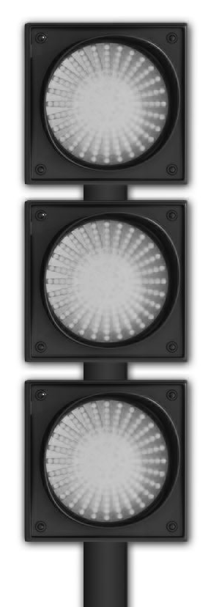 | GO!  NEW!  EW!!!!!!  How to Think, Speak and ACT  to Make Good Things Happen  by Marilyn Schoeman  Discover Green Light®: A new universal language, a mind shift,  a transformational tool, a global movement.
Please PRINT clearly.
Name: ____
Billing Address: __________
City:________________________ State/Province:__________ Zip/Postal Code:___________
Country:__________ Phone:________________ Email: ________
Visa / MasterCard Number____________________________________
Name on Credit Card____________________________________________
Exp. Date_____________________ 3 digit CVV2 on back______________
# Books purchased_____________________ Total amount:____________________________
❒ Mailing address if different from billing address:__________________________________
____________________________________________________________________________
GO! makes a wonderful GIFT!
• For friends, family, colleagues & clients • For all occasions
❒ Yes! I want autographed copies! Please personalize with first names below. (Please PRINT.)
First Name – Book #1 | First Name – Book #2 | First Name – Book #3 | First Name – Book #4

Number of Books ordered | Item Description | Unit Price US $ Dollars | Shipping in USA | Total  1 Book | Total  2 Books | Total 3books | Total  4 books
1 - 4 Books | GO! How to Think Speak and ACT to Make Good Things Happen | $19.95 | $4.95 | $24.90 | $49.80 | $74.70 | $99.60
5 -9 Books | GO! How to Think Speak and ACT to Make Good Things Happen | $19.95 | $2.00 | $21.95  per book | *International orders: Shipping is $9.95 per book.
Washington state residents please add sales tax: $1.90 / book = $21.85 + $4.95 shipping = $26.80
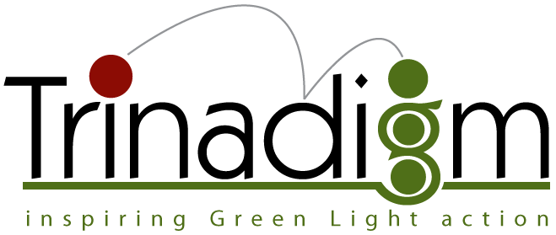
 PO Box 16785  Seattle, WA. 98116  USA  www.GoGreenLightWay.com

GO! How to Think, Speak and ACT
NEW!!!!!! available !
EW!!!!!!

to Make Good Things Happen
by Marilyn Schoeman

Discover Green Light® - A new universal language, a mind shift,
a transformational tool, a global movement.

GO! Imagine cruising through your world, changing Red Light signals into Green Light ones. That’s the power of the Green Light® Way. Simple. Quick. Profound. It works - everywhere!

The Green Light® system gives you instant access to more of life’s riches—greater success, better relationships, expanding joy. It empowers you to do consciously, and by choice, what successful others do by nature, upbringing, and habit. It helps you think, speak and ACT to make good things happen.

In this new breakthrough book, Marilyn introduces Green Light, a new universal language and transformational tool. Based on 9 key principles, the Green Light approach enables you to:
- Transform the status quo into Status GO!
- Convert negativity & pessimism into Constructive ACTION.
- Move from unsatisfactory results to Expanded success
- Elevate automatic responses to Conscious intentions, choices and actions.
- Avoid worst case scenarios Identify and move toward Ideal Scenarios.

In every situation, the Green Light Way is a highly effective tool for super-charging your personal and professional success. A business person’s corporate challenge, a mom’s home-based venture, a partner’s relationship, a student’s exam or an athlete’s competitive event—all, and countless more, are well-served by using the Green Light method. Give the gift of GO! Share it with teammates. Upgrade the environment around you.

The Green Light Way changes lives in minutes! Green up your future. Where do you want to GO!?
Author Marilyn Schoeman is described as a visionary think tank. She is a recipient of the “Champion of Creativity Award” from the American Creativity Association (ACA). Often called the Green Light Lady, she is the founder and principal consultant of Trinadigm whose mission is to dramatically expand practical creativity, personal fulfillment and super-charge business success.
Delighting audiences at a wide variety of conferences, business events and educational summits, Schoeman delivers presentations around the globe. Her clients include Helsinki University, IBM, Harborview Medical Center, REI, Rockwell International, DuPont, Boeing, ACED, SMPS, Young President’s Association and Yan Shan University/China.

Order Your Copy of GO! Today! Get more Green Light signals!
 PO Box 16785  Seattle, WA. 98116  USA  www.GoGreenLightWay.com

